EXPERIMENT – 1

1. Write a Java program that implements Quick sort algorithm for sorting a list of names in ascending order
class Main {

static int partition(String[] names, int low, int high) {
String pivot = names[high];
int i = low - 1;

for (int j = low; j <= high - 1; j++) {
if (names[j].compareTo(pivot) < 0) {
i++;
swap(names, i, j);
}
}

swap(names, i + 1, high);
return i + 1;
}

static void swap(String[] names, int i, int j) {
String temp = names[i];
names[i] = names[j];
names[j] = temp;
}

static void quickSort(String[] names, int low, int high) {
if (low < high) {
int pivot = partition(names, low, high);
quickSort(names, low, pivot - 1);
quickSort(names, pivot + 1, high);
}
}

public static void main(String[] args) {
String[] names = {
"Anvesh", "Kaushik", "Mahira", "Shweta", "Prachi", "Shubham", "Gurvir", "Ibrahim"
};

System.out.println("Before Sorting: ");
for (int i = 0; i < names.length; i++) {
System.out.println(names[i]);
}

quickSort(names, 0, names.length - 1);

System.out.println();
System.out.println("After Sorting: ");
for (int i = 0; i < names.length; i++) {
System.out.println(names[i]);
}
}
}

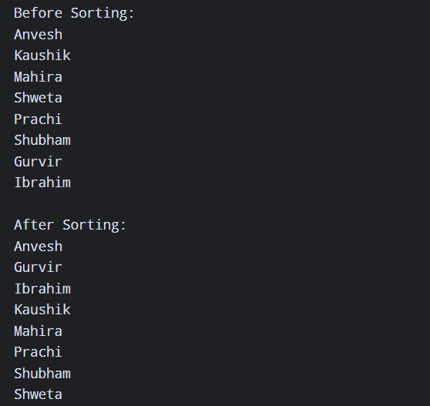
OUTPUT:

Figure 1: Output of program 1

EXPERIMENT – 2

2. Write a Java program that implements Bubble sort algorithm for sorting in descending order and also shows the number of interchanges occurred for the given set of integers.
public class BubbleSort {
static void sort(int[] a) {
int interchange = 0;

for (int i = 0; i < a.length - 1; i++) {
for (int j = 0; j < a.length - 1 - i; j++) {
if (a[j] < a[j + 1]) {
int temp = a[j];
a[j] = a[j + 1];
a[j + 1] = temp;
interchange++;
}
}
}

System.out.println("Number of interchanges: " + interchange);
}

public static void main(String[] args) {
int[] a = {10, 5, 20, 8, 15};

System.out.println("Array before sorting:");
for (int i = 0; i < a.length; i++) {
System.out.print(a[i] + " ");
}
System.out.println();

sort(a);

System.out.println("Array after sorting:");
for (int i = 0; i < a.length; i++) {
System.out.print(a[i] + " ");
}
}
}
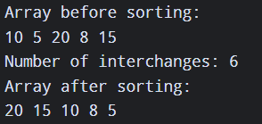
OUTPUT:
Figure 2: Output of program 2

EXPERIMENT – 3

3. Write a Java program that prompts the user for an integer and then prints out all the prime numbers up to that Integer.
import java.util.Scanner;

class PrimeNumbers {
public static void main(String[] args) {
Scanner sc = new Scanner(System.in);

System.out.print("Enter a number: ");
int num = sc.nextInt();

System.out.println("Prime numbers from 1 to " + num + " are:");

for (int i = 2; i <= num; i++) {
boolean isPrime = true;

for (int j = 2; j * j <= i; j++) {
if (i % j == 0) {
isPrime = false;
break;
}
}

if (isPrime) {
System.out.print(i + " ");
}
}

sc.close();
}
}

OUTPUT:
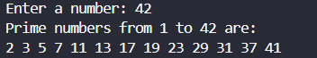
Figure 3: Output of program 3

EXPERIMENT – 4

4. Write a Java program that checks whether a given string is a palindrome or not. Ex: MADAM is a palindrome.
import java.util.Scanner;

class Palindrome {
public static void main(String[] args) {
Scanner sc = new Scanner(System.in);

System.out.print("Enter a string: ");
String str = sc.next().toLowerCase();

boolean isPalindrome = true;
int j = str.length() - 1;
for(int i = 0; i < str.length() / 2; i++) {
if(str.charAt(i) != str.charAt(j--)) {
isPalindrome = false;
break;
}
}

if(isPalindrome) {
System.out.println(str + " is a palindrome.");
} else {
System.out.println(str + " is not a palindrome");
}

sc.close();
}
}

OUTPUT:


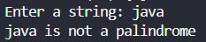
Figure 4: Output of program 4

EXPERIMENT – 5

5. Write a Java program that works as a simple calculator. Use a grid layout to arrange buttons for the digits and for the +, -, *, % operations. Add a text field to display the result. Handle any possible exceptions like divided by zero.
import java.awt.*;
import java.awt.event.*;
import javax.swing.JOptionPane;

public class Calculator implements ActionListener{
Frame frame;
TextField display;
Button[] digitButtons = new Button[10];
Button add, subtract, multiply, divide, clear, modulo, equalTo;
double num1, num2, result;
char operator;
boolean calculationDone = false;

public Calculator() {
frame = new Frame("Calculator");
frame.addWindowListener(new WindowAdapter() {
@Override
public void windowClosing(WindowEvent e) {
frame.dispose();
System.exit(0);
}
});

display = new TextField();
display.setEditable(false);
display.setFont(new Font("Arial", Font.BOLD, 25));
frame.add(display, BorderLayout.NORTH);

Panel panel = new Panel();
panel.setLayout(new GridLayout(4, 4));
for (int i = 0; i <= 9; i++) {
digitButtons[i] = new Button(String.valueOf(i));
digitButtons[i].addActionListener(this);
}

add = new Button("+");
subtract = new Button("-");
multiply = new Button("*");
divide = new Button("/");
modulo = new Button("%");
equalTo = new Button("=");
clear = new Button("C");

add.addActionListener(this);
subtract.addActionListener(this);
multiply.addActionListener(this);
divide.addActionListener(this);
modulo.addActionListener(this);
equalTo.addActionListener(this);
clear.addActionListener(this);

panel.add(digitButtons[7]);
panel.add(digitButtons[8]);
panel.add(digitButtons[9]);
panel.add(divide);

panel.add(digitButtons[4]);
panel.add(digitButtons[5]);
panel.add(digitButtons[6]);
panel.add(multiply);

panel.add(digitButtons[1]);
panel.add(digitButtons[2]);
panel.add(digitButtons[3]);
panel.add(subtract);

panel.add(digitButtons[0]);
panel.add(add);
panel.add(modulo);
panel.add(equalTo);

frame.add(panel, BorderLayout.CENTER);

frame.add(clear, BorderLayout.SOUTH);

frame.setSize(400, 400);
frame.setVisible(true);
}

@Override
public void actionPerformed(ActionEvent e) {
String command = e.getActionCommand();

try {
if(command.charAt(0) >= '0' && command.charAt(0) <= '9') {
if (calculationDone) {
display.setText("");
calculationDone = false;
operator = '\0';
}
display.setText(display.getText() + command);
}

else if (command.equals("C")) {
display.setText("");
num1 = 0;
num2 = 0;
result = 0;
operator = '\0';
calculationDone = false;
}

else if (
command.equals("/") ||
command.equals("*") ||
command.equals("+") ||
command.equals("-") ||
command.equals("%")
) {
if (display.getText().isEmpty()) {
throw new NumberFormatException("Enter a number before choosing an operator");
}

num1 = Double.parseDouble(display.getText());
operator = command.charAt(0);
calculationDone = false;
display.setText("");
}

else if (command.equals("=")) {
if (operator == '\0') {
throw new NumberFormatException("Choose an operator");
}

if (!calculationDone && display.getText().isEmpty()) {
throw new NumberFormatException("Enter some number first");
}

if (!calculationDone) {
num2 = Double.parseDouble(display.getText());
}

switch(operator) {
case '+':
result = num1 + num2;
break;
case '-':
result = num1 - num2;
break;
case '*':
result = num1 * num2;
break;
case '/':
if(num2 == 0) {
throw new ArithmeticException("Cannot divide by zero");
}
result = num1 / num2;
break;
case '%':
if(num2 == 0) {
throw new ArithmeticException("Cannot divide by zero");
}
result = num1 % num2;
break;
}

display.setText(String.valueOf(result));
num1 = result;
calculationDone = true;
}

} catch (ArithmeticException ex) {
JOptionPane.showMessageDialog(
frame,
ex.getMessage(),
"Arithmetic Error",
JOptionPane.ERROR_MESSAGE
);
display.setText("");
return;

} catch (NumberFormatException ex) {
JOptionPane.showMessageDialog(
frame,
ex.getMessage(),
"Input Error",
JOptionPane.ERROR_MESSAGE
);
return;
}
}

public static void main(String[] args) {
new Calculator();
}
}

OUTPUT:
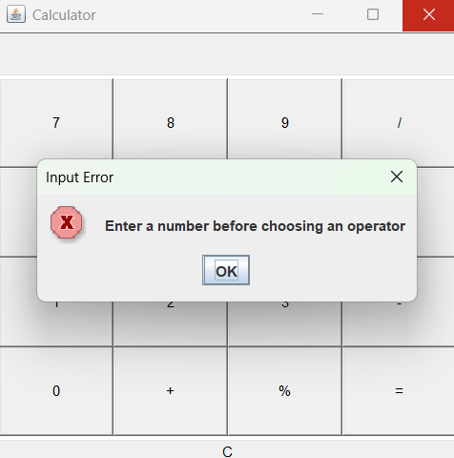
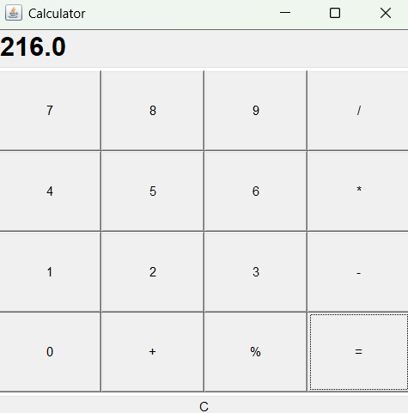
0

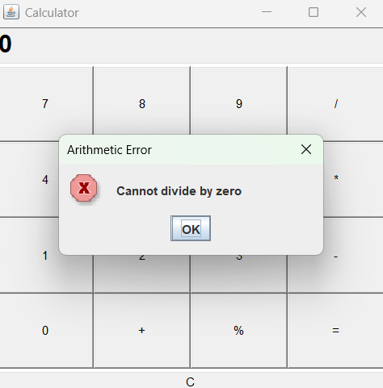
Figure 5: Output of program 5

EXPERIMENT – 6

6. Write a Java program that creates a user interface to perform integer divisions. The user enters two numbers in the text fields, Num1 and Num2. The division of Num1 and Num 2 is displayed in the Result field when the Divide button is clicked. If Num1 or Num2 were not an integer, the program would throw a Number Format Exception. If Num2 were Zero, the program would throw an Arithmetic Exception. Display the exception in a message dialog box.

